WEEK 5  
HANDS ON

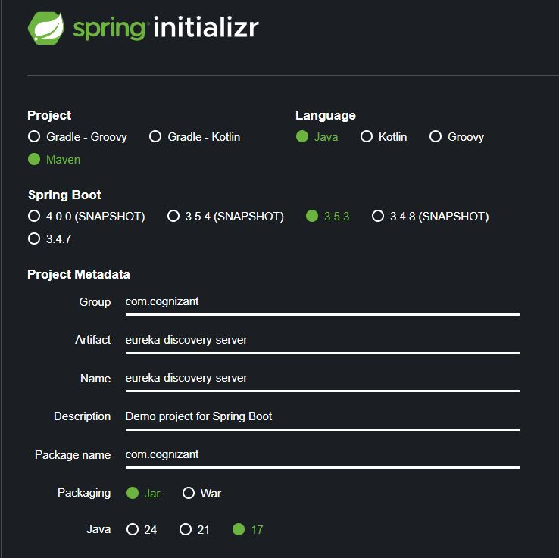

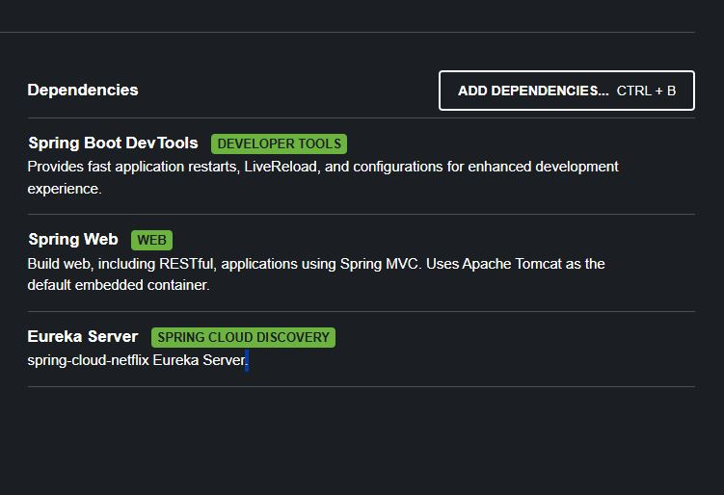

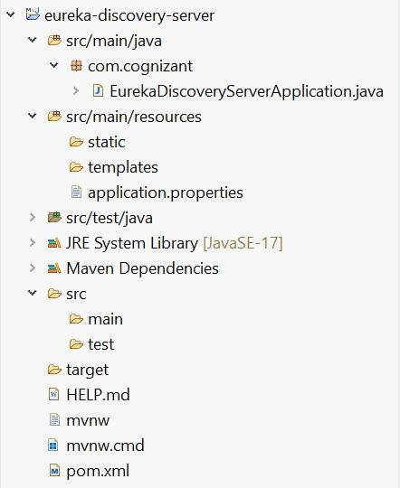

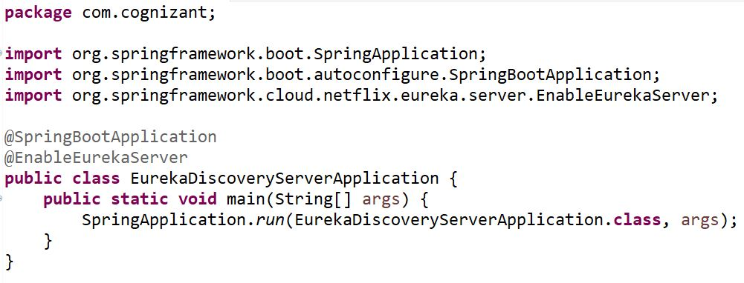

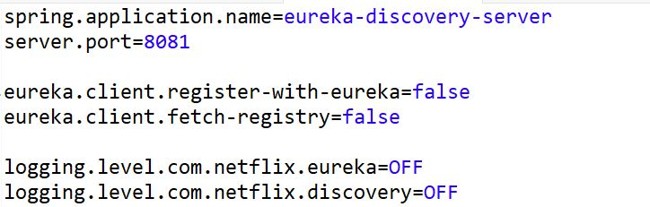

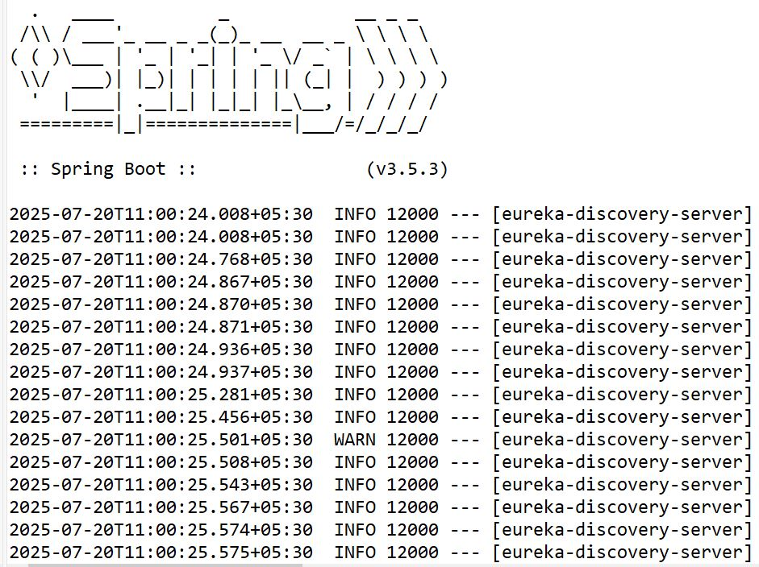

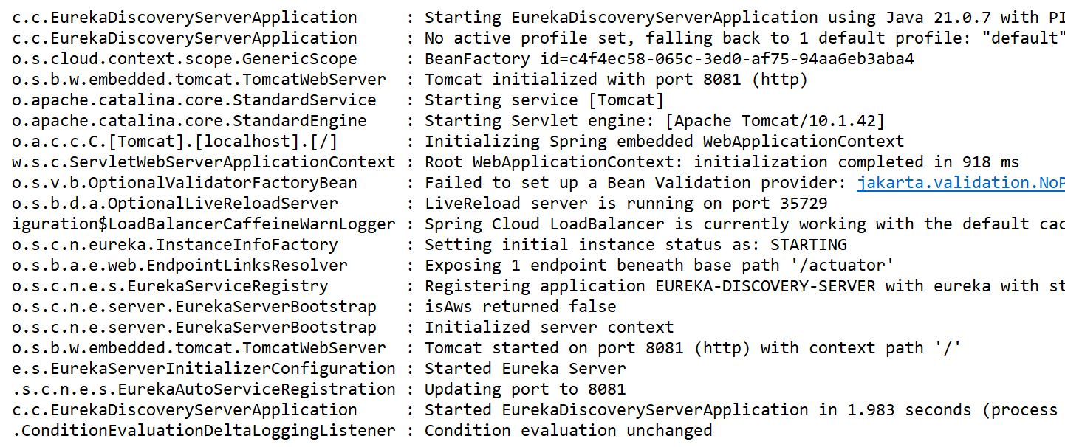

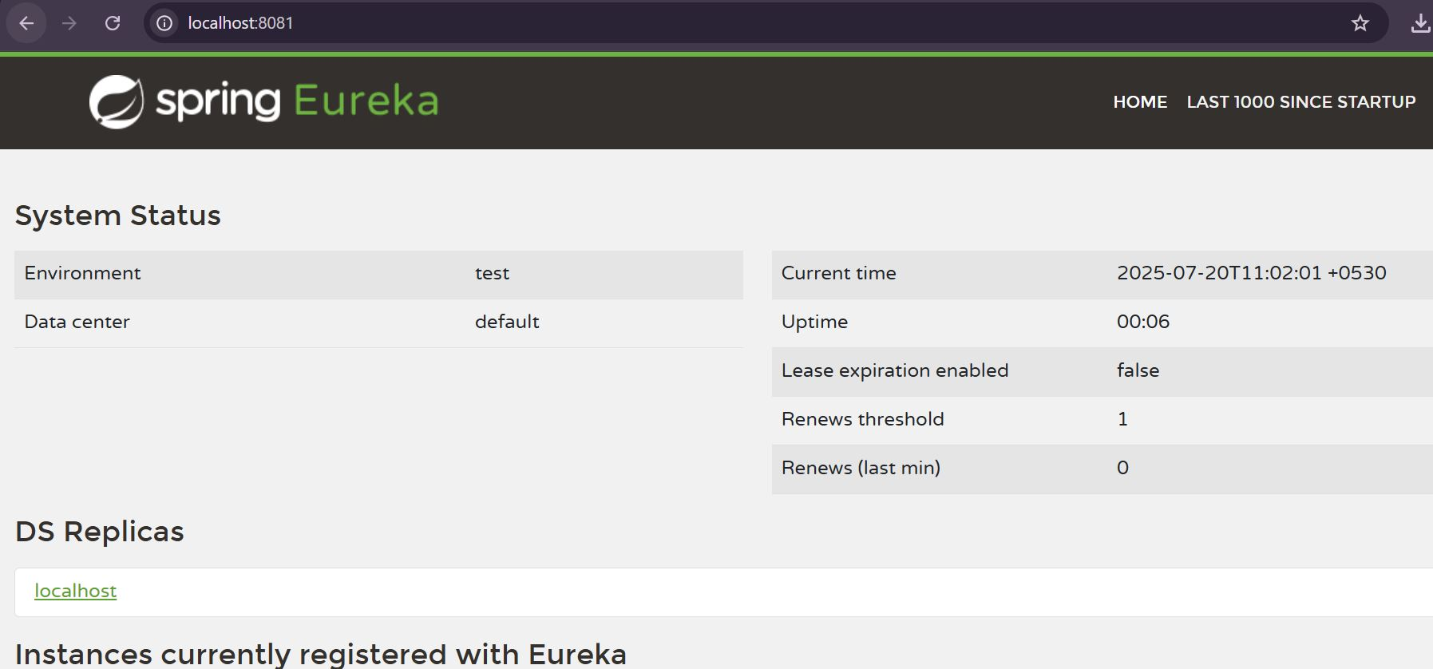

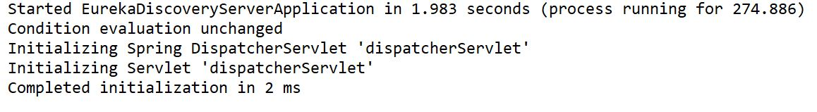

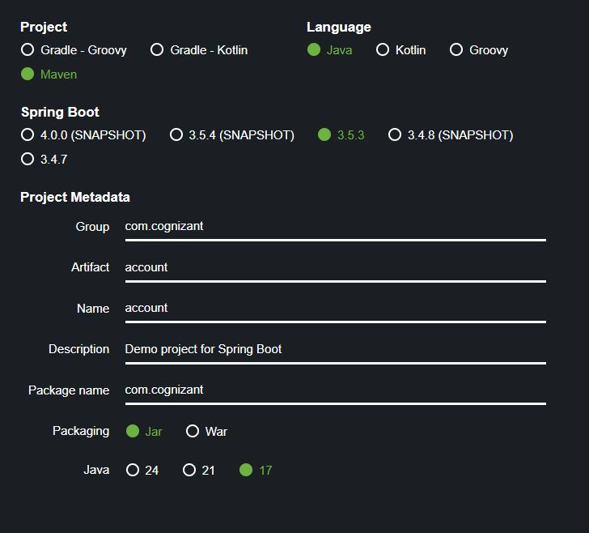

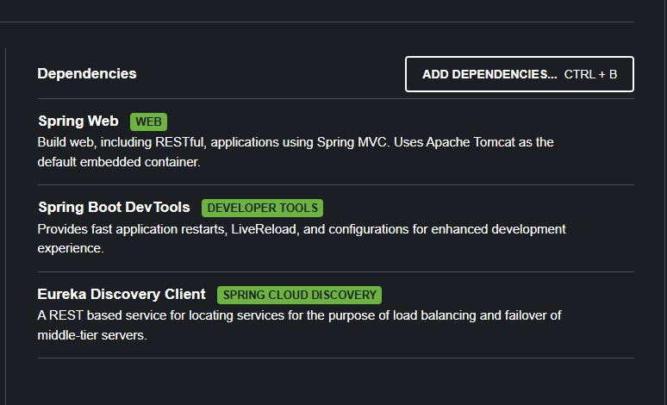

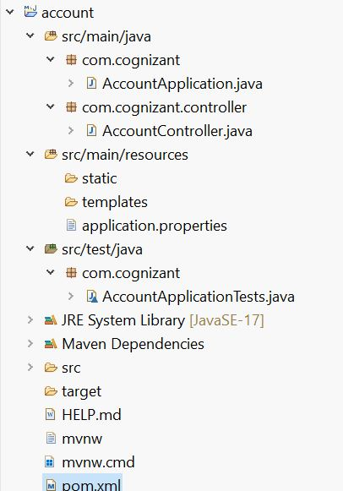

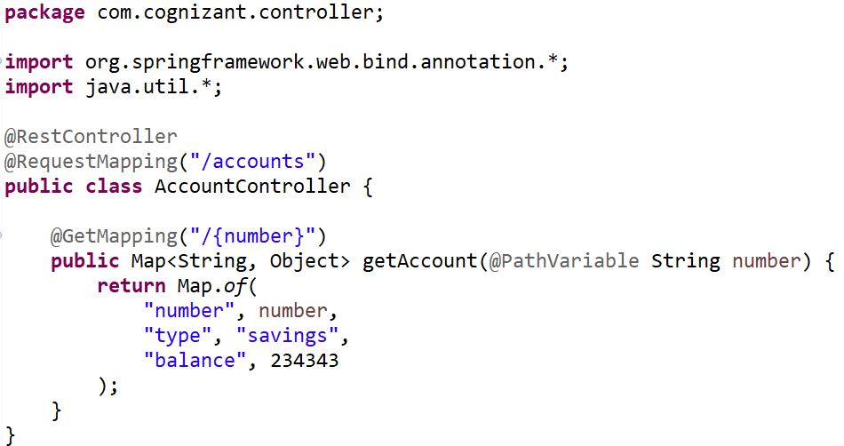



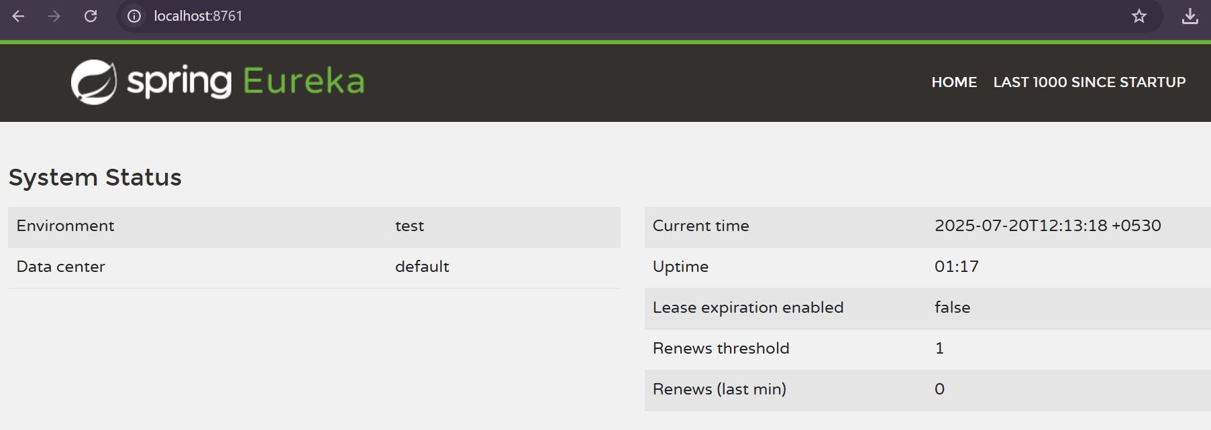

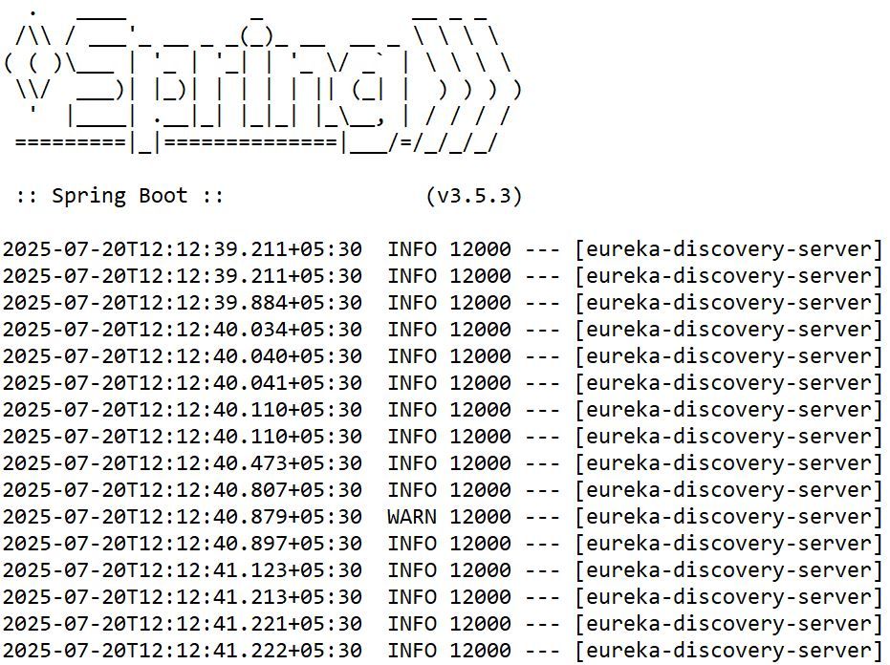

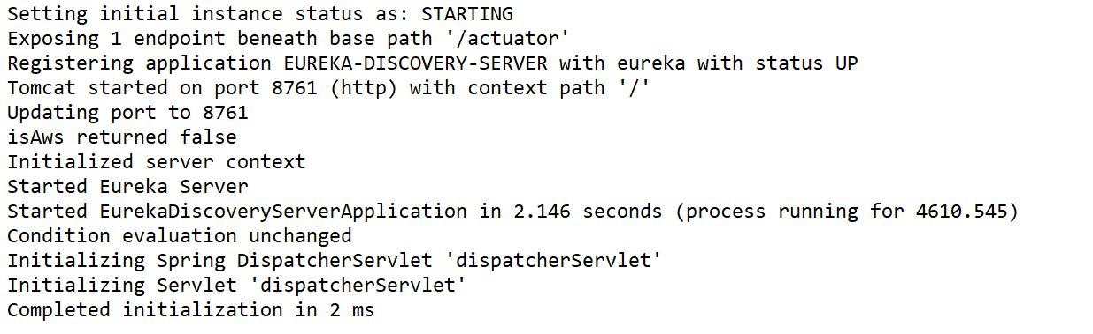

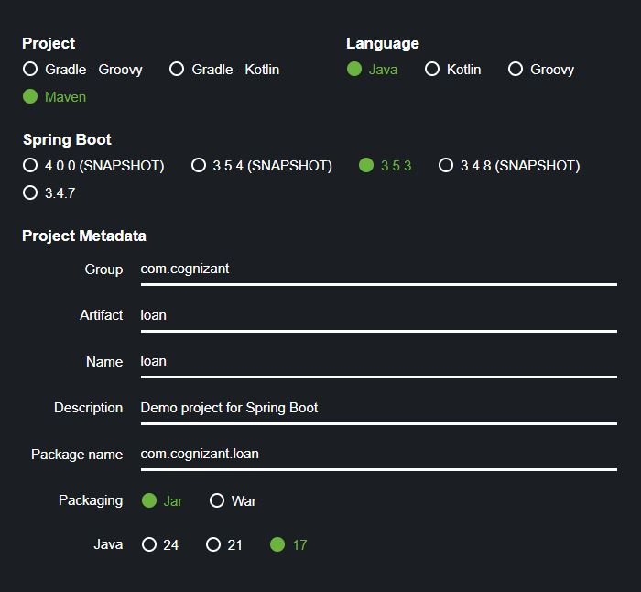

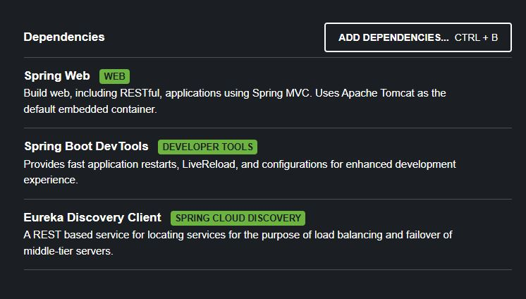

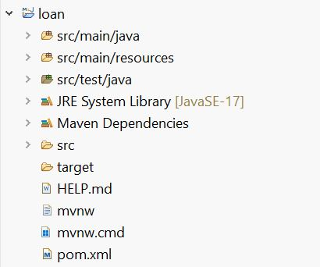

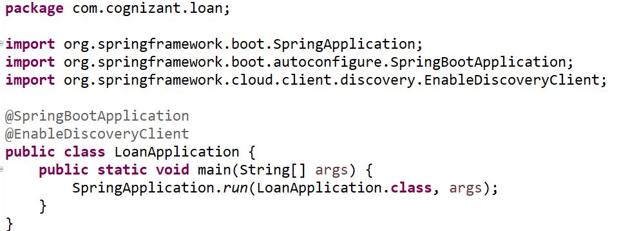

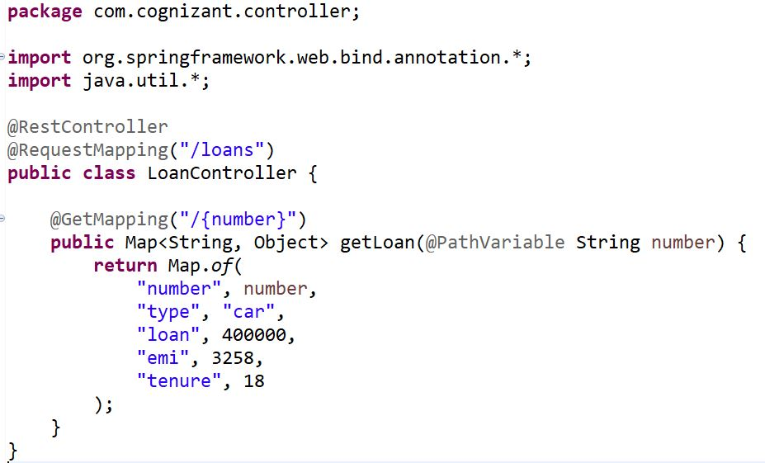

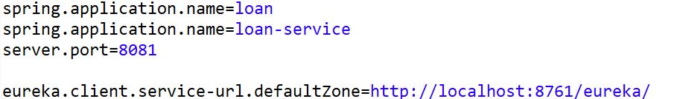

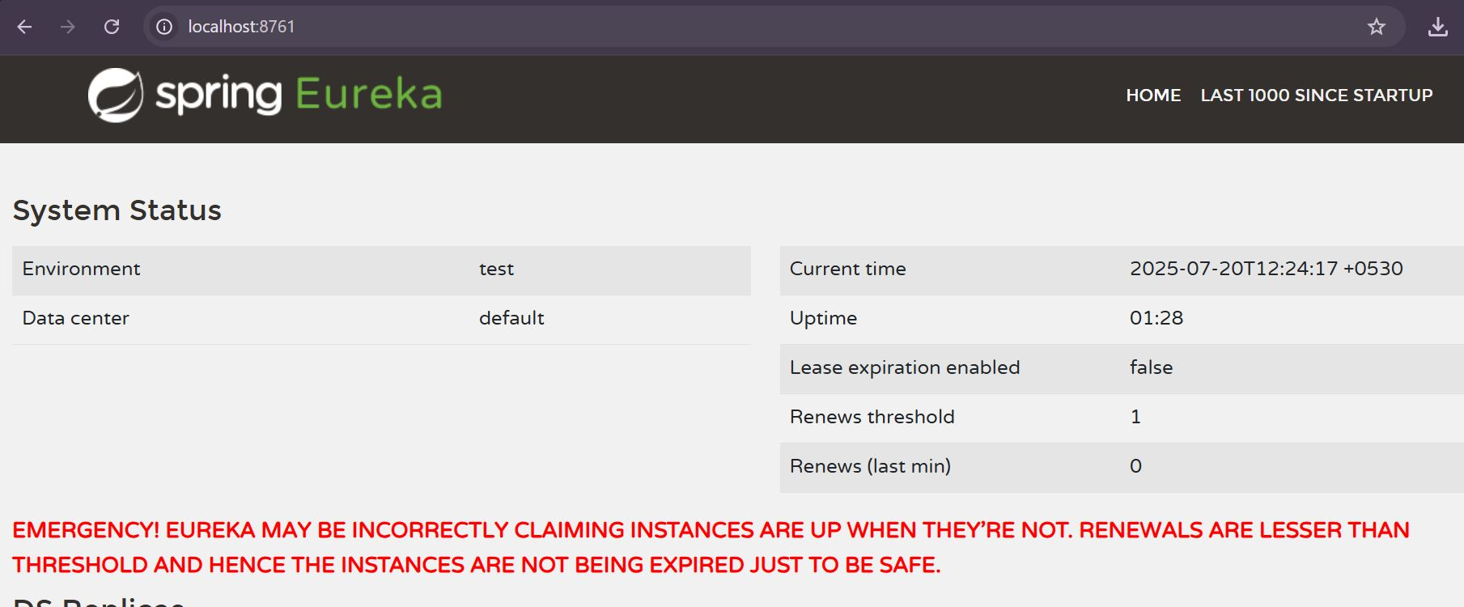

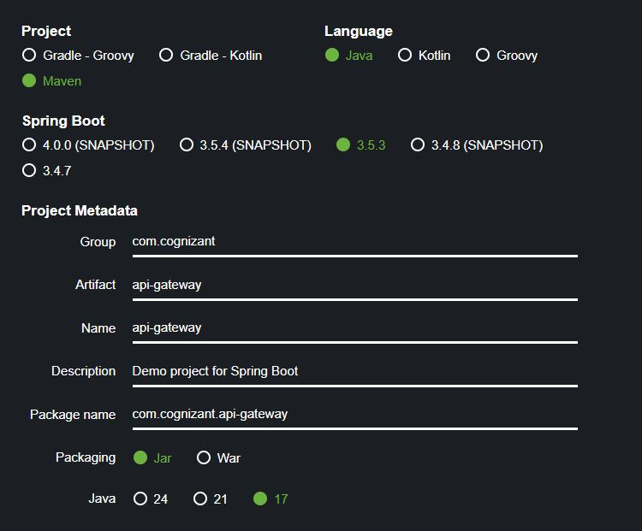

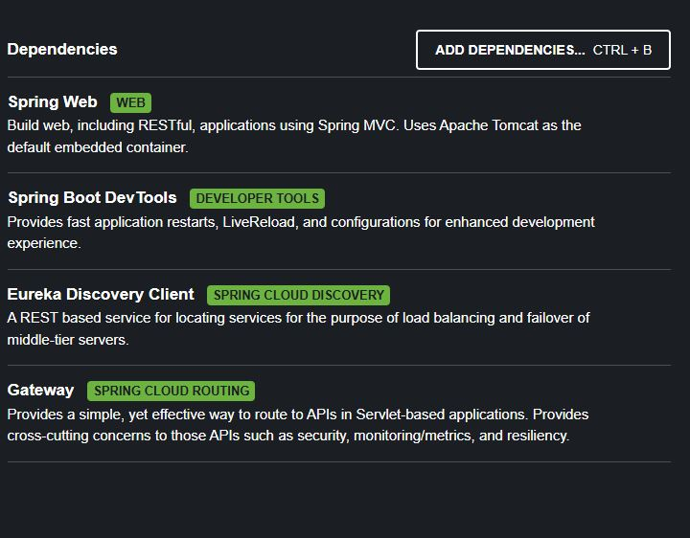

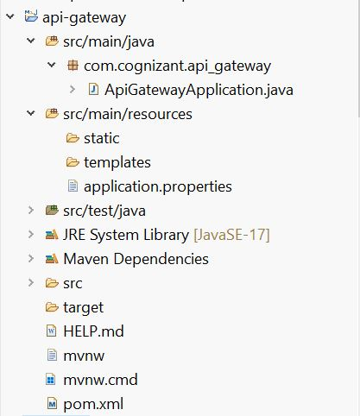

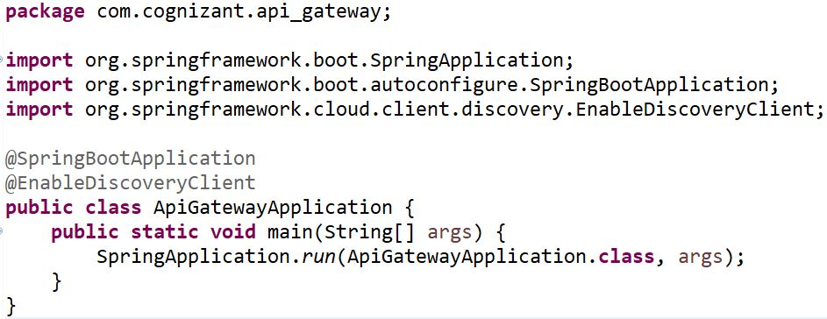

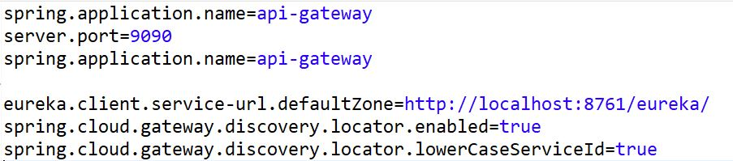

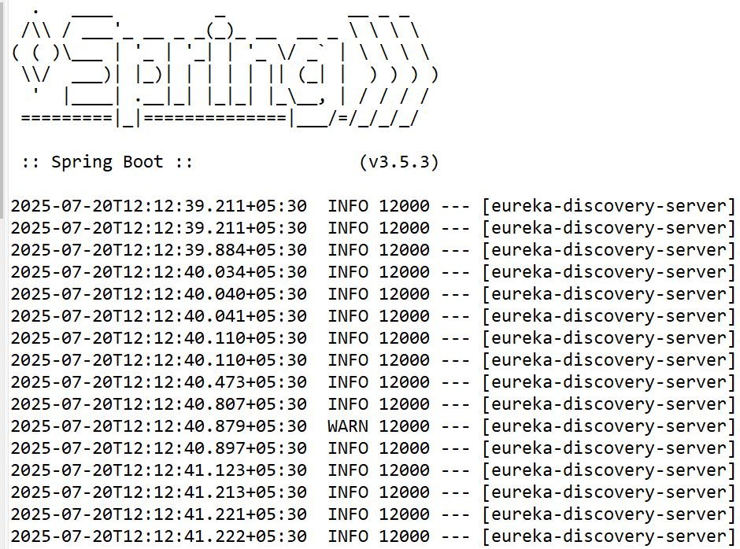

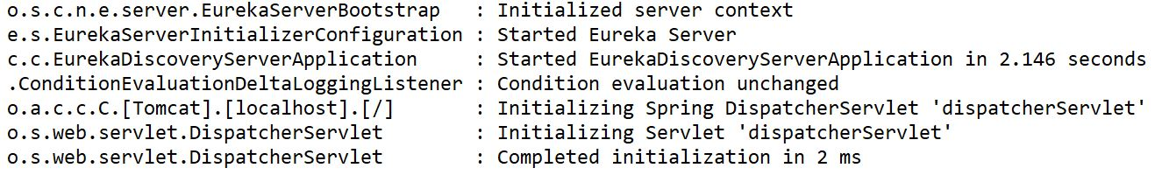

package com.cognizant.filter;

import org.slf4j.Logger;

import org.slf4j.LoggerFactory;

import org.springframework.cloud.gateway.filter.GlobalFilter;

import org.springframework.cloud.gateway.filter.GatewayFilterChain;

import org.springframework.core.annotation.Order;

import org.springframework.stereotype.Component;

import org.springframework.web.server.ServerWebExchange;

import reactor.core.publisher.Mono;

@Component

@Order(1)

public class LogFilter implements GlobalFilter {

private static final Logger logger = LoggerFactory.getLogger(LogFilter.class);

@Override

public Mono<Void> filter(ServerWebExchange exchange, GatewayFilterChain chain) {

logger.info("Request Path: {}", exchange.getRequest().getPath());

logger.info("Request Method: {}", exchange.getRequest().getMethod());

return chain.filter(exchange);

}

}

Port: <http://localhost:9090/account-service/accounts/123456>

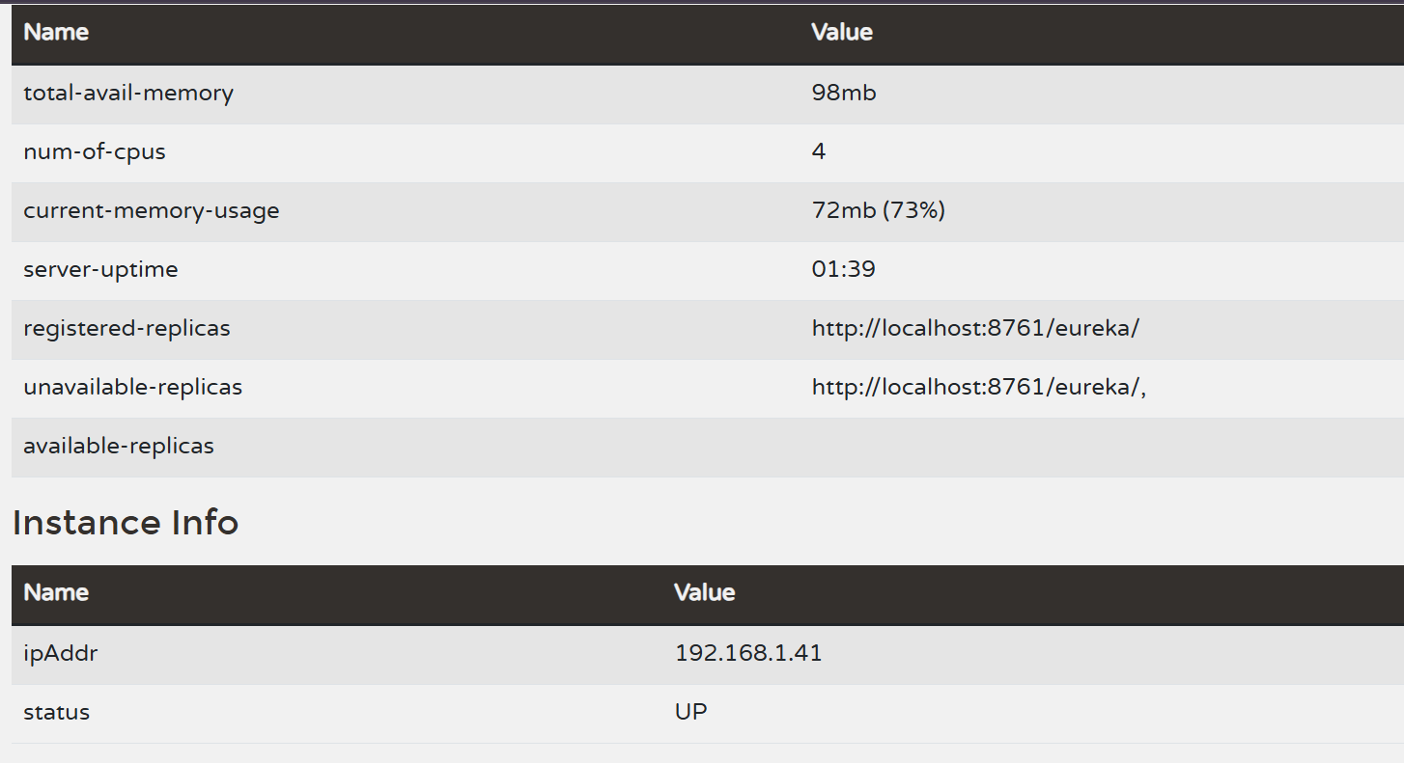

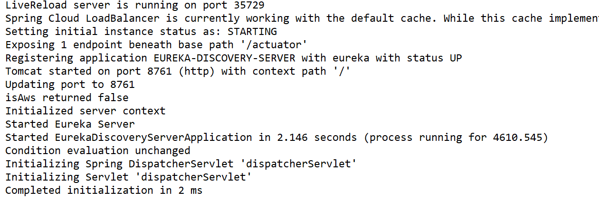

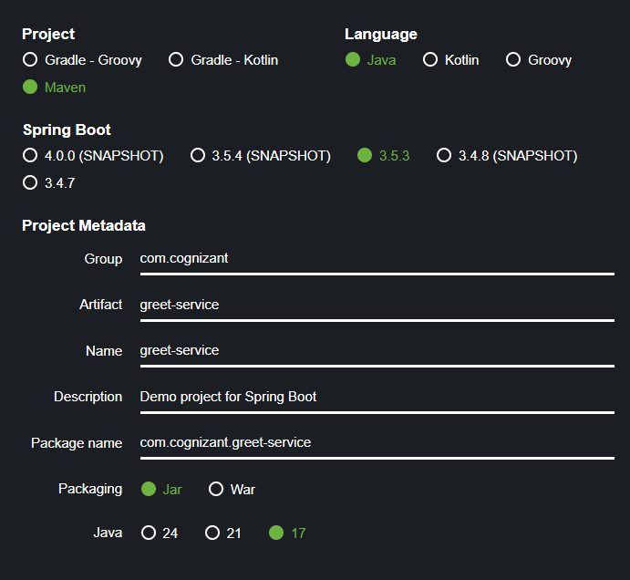

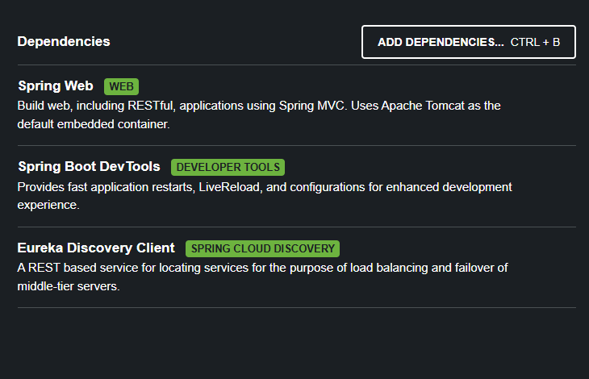

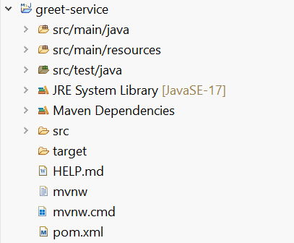

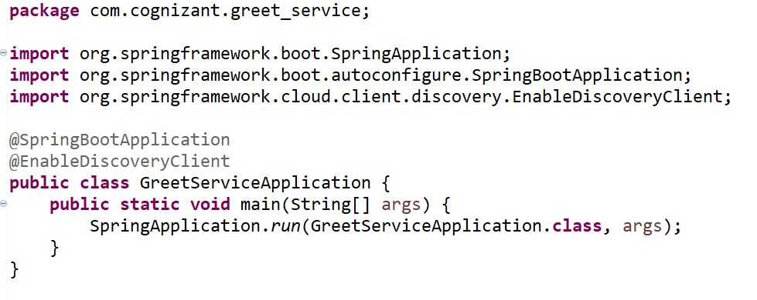

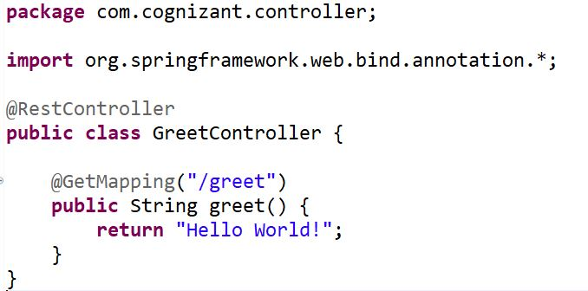



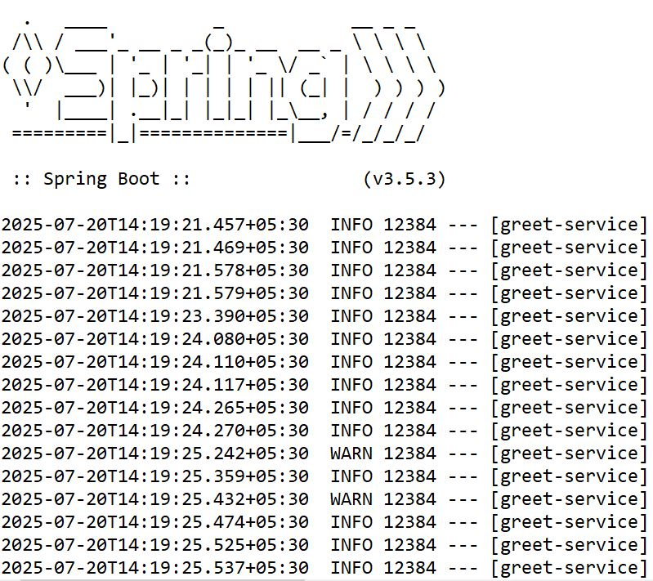

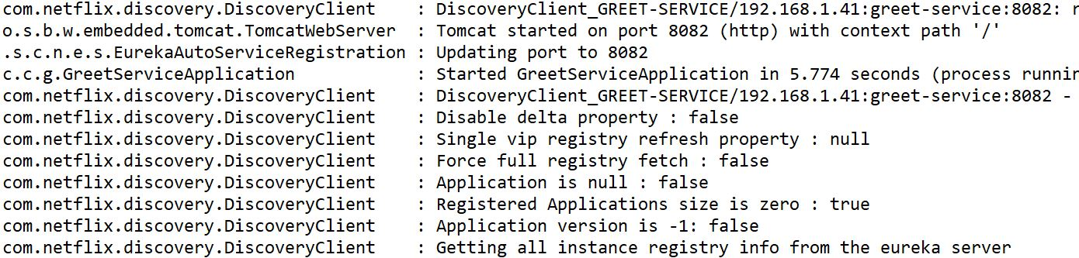

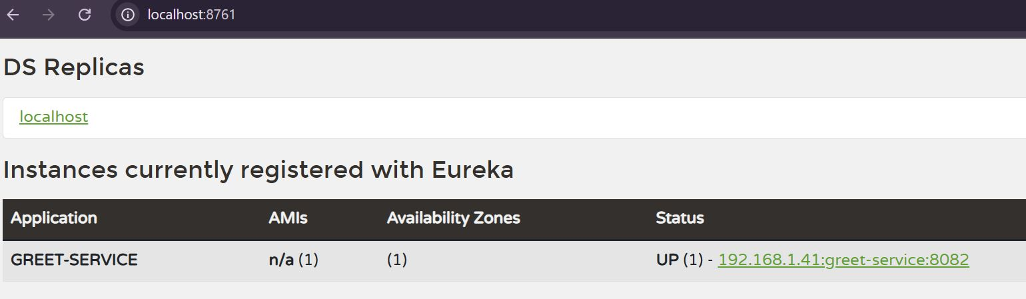

OUTPUT:

Hello World!

**2. Microservice REST API Outputs**

**Account Service**

<http://localhost:8080/accounts/123456>

{

"number": "123456",

"type": "savings",

"balance": 234343

}

**Loan Service**

<http://localhost:8081/loans/H98765>

{

"number": "H98765",

"type": "car",

"loan": 400000,

"emi": 3258,

"tenure": 18

}